December 8, 2023
Rank | Magnitude | Date | Start | Max | End
1 | X2.25 | 4/20/2022 | 03:41 | 03:57 | 04:04
2 | X1.5 | 5/10/2022 | 13:50 | 13:55 | 13:59
3 | X1.3 | 3/30/2022 | 17:21 | 17:37 | 17:46
4 | X1.1 | 5/3/2022 | 13:08 | 13:25 | 13:31
5 | X1.1 | 4/30/2022 | 13:37 | 13:47 | 13:52
6 | X1.1 | 4/17/2022 | 03:17 | 03:34 | 03:51
7 | X1 | 10/2/2022 | 19:53 | 20:25 | 20:34
8 | M9.7 | 4/21/2022 | 01:47 | 01:59 | 02:05
9 | M9.67 | 3/31/2022 | 18:17 | 18:35 | 18:45
10 | M8.77 | 10/2/2022 | 02:08 | 02:21 | 02:26

https://www.spaceweatherlive.com/en/solar-activity/top-50-solar-flares/year/2022.html

Using new files provided by Bob Gerzoff
Layout:

Data Mapping for WSPR
Column Name | Source field from database (starts with 0) – See Appendix A | Destination field (starts with 1)
datetime | (0) datetime (UTC) | (1) Datetime (UTC)
datetime | (0) datetime (UTC) | Format YYYY-MM-DDThh:mm:ss
Tcall | (7) Callsign (sender) | (2) transmitting call
Tgrid | (8) sender grid | (3) transmitting grid
Tlat | Calculate from grid | (4) transmitting latitude
Tlang | Calculate from grid | (5)transmitting longitude
Tgridsrc | W | (6)transmitting source of grid info
Rcall | (3) Callsign of Reporter | (7) receiving call
Rgrid | (4) reporter grid | (8) receiving grid
Rlat | Calculate from grid | (9) receiving latitude
Rlon | Calculate from grid | (10) receiving longitude
Rgridsrc | W | (11) receiving source of grid info
Freq | (6) Mhz X 1,000,000 | (12) frequency (Hz)
SNR | (5) db | (13) SNR
Mode | W | (14) mode
 | W | (15) source
 | null | (16) sender Status
 | null | (17) iMD
 | null | (18) ipOriginID
 | null | (19) senderMobileLocator
 | null | (20) c1
 | null | (21) c2
 | W | (22) mode2
 | (11) distance | (23)path length (km) assuming short path
 |  | Computed fields:
 |  | (24)latitude of signal center point
 |  | (25)Longitude of signal center point

Summary of file processing:

“Datetime”,”Tcall”,”Tgrid”,“Tlat”,“Tlang”,“Tgridsrc”,“Rcall”,“Rgrid”,“Rlat”,“Rlon’,“Rgridsrc”,“Freq”,“SNR”,“Mode”

from csv import reader
import csv
import datetime
import re
outf = open('C:\\Documents\\HAMSCIData\\WSPR data\\WSPR2022v2\\NorthAmerica.csv','at', newline='')
write=csv.writer(outf)
indir = 'C:\\Documents\\HAMSCIData\\WSPR data\\WSPR2022v2\\'
infile = indir+"2022-03-30_WSPR.csv"
legal_gridsquares = ["CN","CM","DN","DL","DM","EN","EM","EL","FN","FM","FL"]
print(infile)
with open(infile,'r') as WSPRfile:
WSPRcsv = reader(WSPRfile)
for row in WSPRcsv:
Tgrid = row[2][0:4]
Rgrid = row[7][0:4]
Tgridpre = Tgrid[0:2]
Rgridpre = Rgrid[0:2]
if Tgridpre in legal_gridsquares:
if Rgridpre in legal_gridsquares:
row.append(Tgrid)
row.append(Rgrid)
row=list(filter(None,row))
write.writerow(row)
WSPRfile.close()
outf.close()
print("Done")

fnNA <- "C:\\Documents\\HAMSCIData\\WSPR data\\WSPR2022v2\\NorthAmerica.csv"
NAQSOS <- read.csv(fnNA)
names(NAQSOS) <- c("Datetime", "Tcall", "Tgrid", "Tlat", "Tlang", "Tgridsrc", "Rcall", "Rgrid", "Rlat", "Rlon", "Rgridsrc", "Freq", "SNR", "Mode","x1","dist","x3","x4","TG04","RG04")

NAQSOS$hrmin <- NAQSOS$hr + (NAQSOS$min/60)
meter40 <- NAQSOS[NAQSOS$band == 7, ]
NAQSOS$band <- trunc(NAQSOS$Freq/1000000)
SNRbyHR <- aggregate(NAQSOS$SNR, list(NAQSOS$hr), FUN = mean)
plot(SNRbyHR$Group.1, SNRbyHR$x)
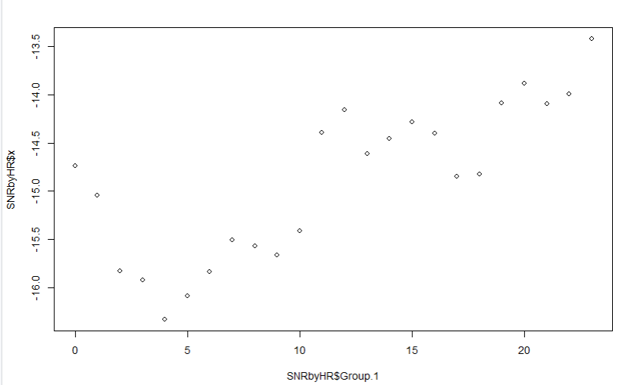
plot(NAQSOS$hrmin, NAQSOS$SNR)
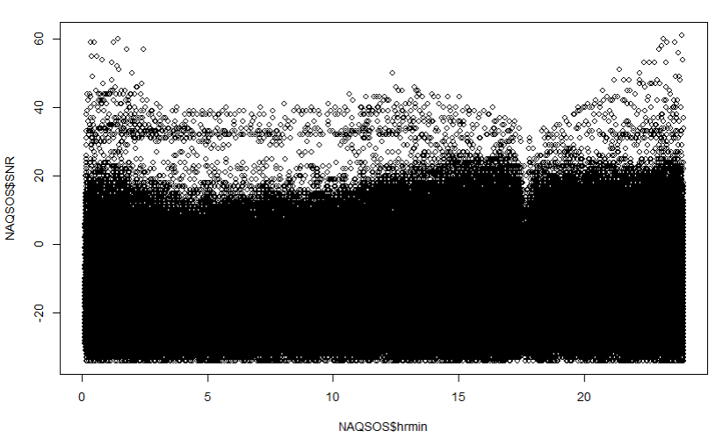
plot(meter40$hrmin, meter40$SNR)
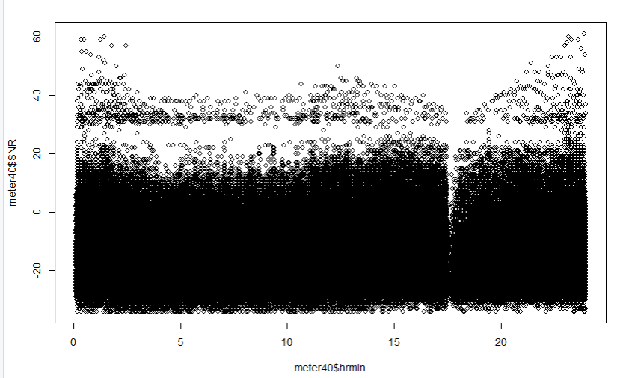

January 20 2024

Cut data set by distance:
Line of Sight
meter40LT100m <- meter40[meter40$x2 >1 && meter40$x2 <100,]
NVIS 100 to 500 miles
meter40LT500m <- meter40[meter40$x2 >100 & meter40$x2 < 500,]
E-layer 500 to 1500 miles
meter40LT1500m <- meter40[meter40$x2 >500 & meter40$x2 < 1500,]
F-layer over 1500 miles
meter40GT1500m <- meter40[meter40$x2 > 1500,]

Using lt 100 miles as a test:
Summarize SNR by Hour:
l100mSNRbyHR <- aggregate(meter40LT100m$SNR, list(meter40LT100m$hr), FUN = mean)
Plot:
ggplot(l100mSNRbyHR , aes(x = Group.1, y = x) ) +geom_line()
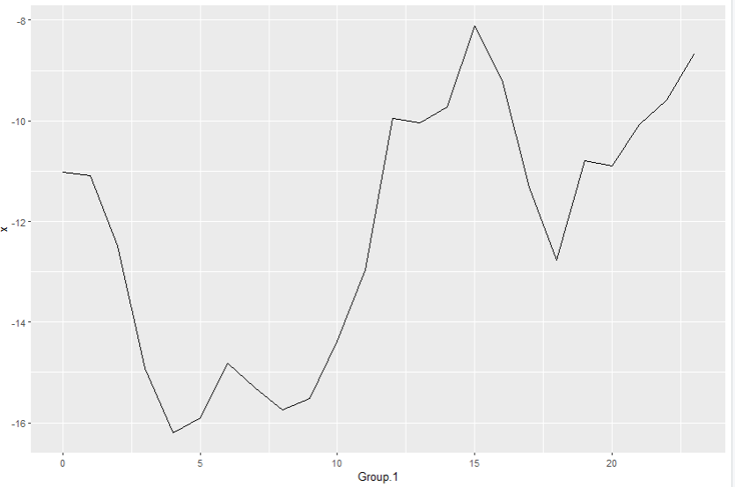

By tenth of an hour:
l100mSNRbyTenthHR <- aggregate(meter40LT100m$SNR, list(meter40LT100m$hrTenth), FUN = mean)
ggplot(l100mSNRbyTenthHR , aes(x = Group.1, y = x) ) +geom_line()
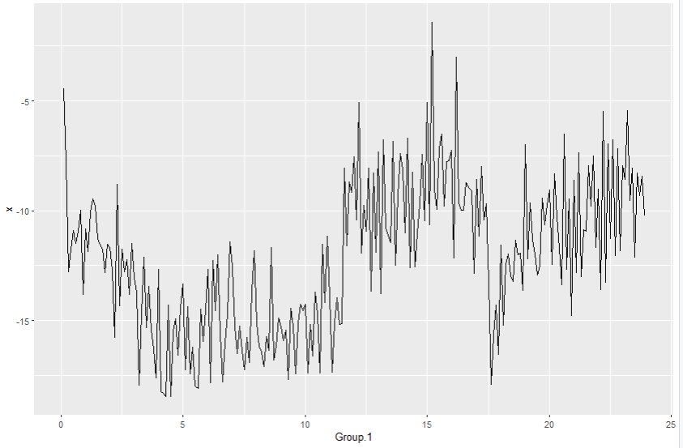

By quarter hour
meter40LT100m$qtrHR <- 15*trunc(meter40LT100m$min/15)+7
meter40LT100m$hrQtr <- meter40LT100m$hr+ (meter40LT100m$qtrHR/60)
l100mSNRbyqtrHR <- aggregate(meter40LT100m$SNR, list(meter40LT100m$hrQtr), FUN = mean)
ggplot(l100mSNRbyqtrHR , aes(x = Group.1, y = x) ) +geom_line()
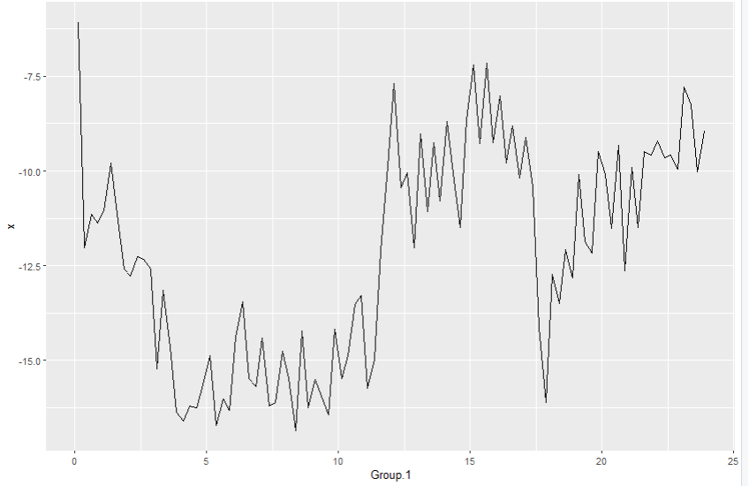

And count of observations by hour:
l100mCNTbyHR <- aggregate(meter40LT100m$SNR, list(meter40LT100m$hr), FUN = length)
ggplot(l100mCNTbyHR , aes(x = Group.1, y = x) ) +geom_line()
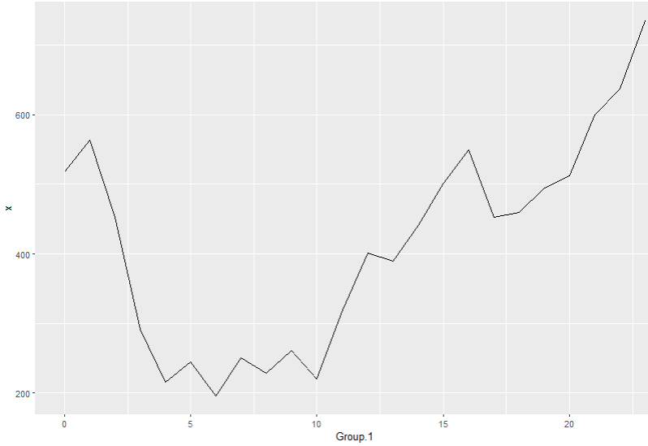

Now for distances over 1500 miles
meter40GT1500m <- meter40[meter40$x2 > 1500,]
GT1500mSNRbyHR <- aggregate(meter40GT1500m$SNR, list(meter40GT1500m$hr), FUN = mean)
ggplot(GT1500mSNRbyHR , aes(x = Group.1, y = x) ) +geom_line()
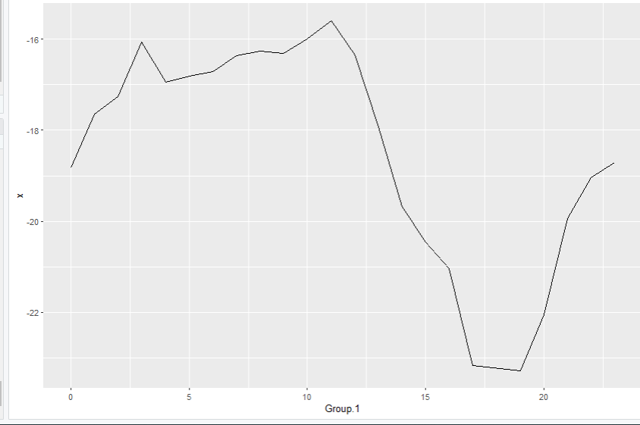

For WSPR obervatins over 1500 miles:

Overall decrease in SNR from hour before flare to hours after

HR UTC
14 | -9.732426
15 | -8.117530
16 | -9.176364
17 | -11.309051
18 | -12.776087
19 | -10.793939

Graph by Grid Square:
> l100mSNRbyGRID <- aggregate(meter40LT100m$SNR, list(meter40LT100m$RG04), FUN = mean)
> View(l100mSNRbyGRID)
> write.csv(l100mSNRbyGRID , "l100mSNRbyGRID .csv", row.names = FALSE)

From hour 16 to hour 17 was a drop of 2.13 Db SNR – formatted with Excel

Time | SNR | Quarter Hour | Minutes of hour
16.1166667 | -8.018634 | 1 | 7
16.3666667 | -9.793893 | 2 | 22
16.6166667 | -8.814159 | 3 | 37
16.8666667 | -10.186207 | 4 | 52
17.1166667 | -9.103448 | 1 | 7
17.3666667 | -10.426667 | 2 | 22
17.6166667 | -14.134615 | 3 | 37
17.8666667 | -16.103896 | 4 | 52
18.1166667 | -12.719697 | 1 | 7
18.3666667 | -13.491228 | 2 | 22
18.6166667 | -12.072072 | 3 | 37
18.8666667 | -12.815534 | 4 | 52
19.1166667 | -10.080745 | 1 | 7

Drop from 17:00 second quarter (conventionally listed as 22 minutes past the hour) and 17:00 third quarter is 3.71 Db SNR. From the second quarter to the 4th is 5.68 dB SNR.

500 to 1500 Miles
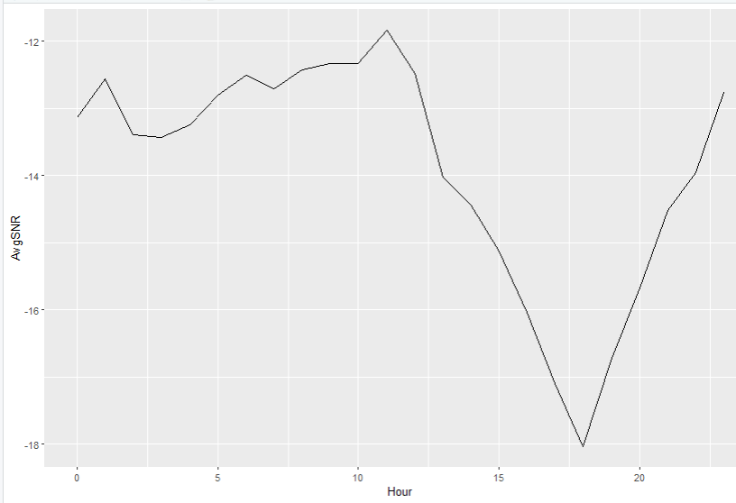

Final Charts
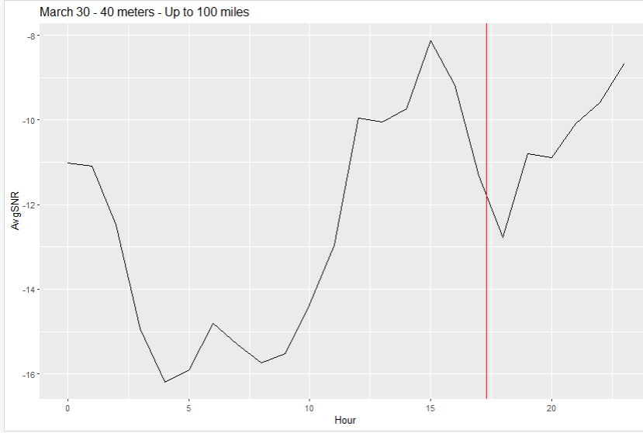

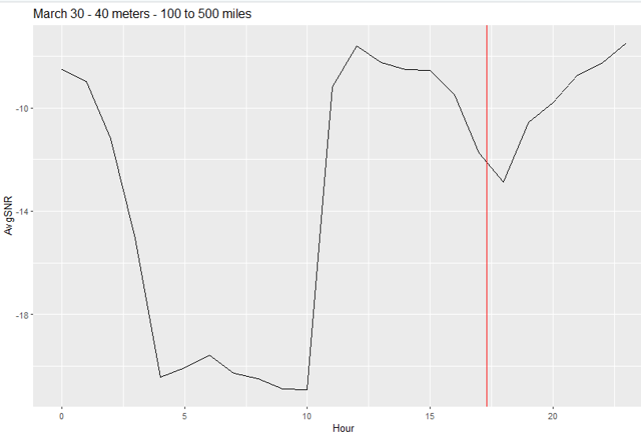

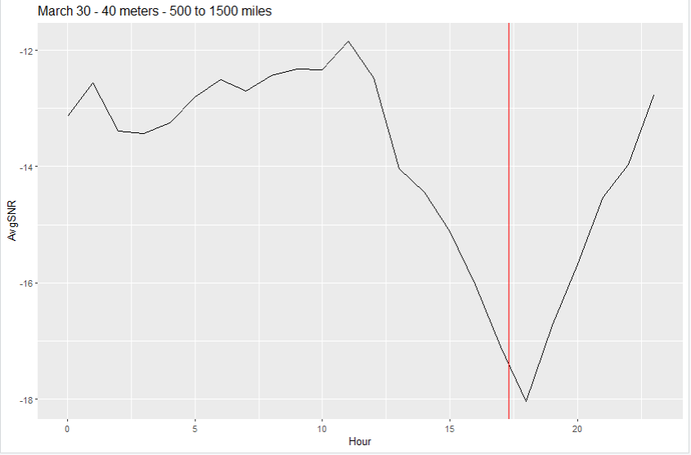
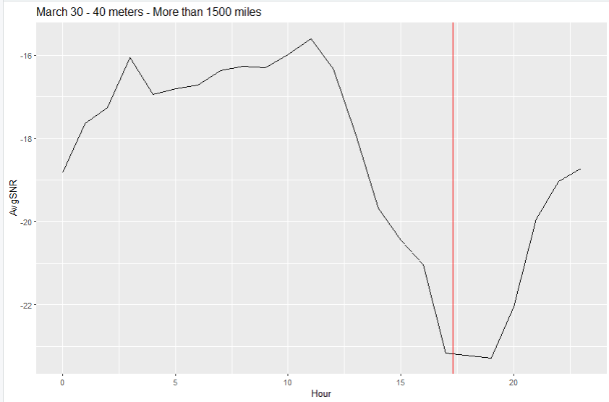

control data

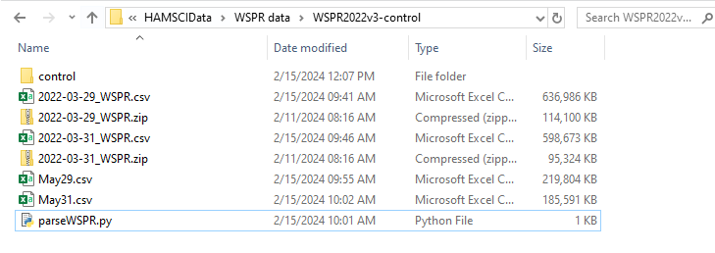

from csv import reader
import csv
import datetime
import re
outf = open('C:\\Documents\\HAMSCIData\\WSPR data\\WSPR2022v3-control\\May31.csv','at', newline='')
write=csv.writer(outf)
indir = 'C:\\Documents\\HAMSCIData\\WSPR data\\WSPR2022v3-control\\'
infile = indir+"2022-03-31_WSPR.csv"
legal_gridsquares = ["CN","CM","DN","DL","DM","EN","EM","EL","FN","FM","FL"]
print(infile)
with open(infile,'r') as WSPRfile:
WSPRcsv = reader(WSPRfile)
for row in WSPRcsv:
Tgrid = row[2][0:4]
Rgrid = row[7][0:4]
Tgridpre = Tgrid[0:2]
Rgridpre = Rgrid[0:2]
if Tgridpre in legal_gridsquares:
if Rgridpre in legal_gridsquares:
row.append(Tgrid)
row.append(Rgrid)
row=list(filter(None,row))
write.writerow(row)
WSPRfile.close()
outf.close()
print("Done")

Mar29fn <- "C:\\Documents\\HAMSCIData\\WSPR data\\WSPR2022v3-control\\May29.csv"
May29 <- read.csv(Mar29fn)
names(May29) <- c("Datetime", "Tcall", "Tgrid", "Tlat", "Tlang", "Tgridsrc", "Rcall", "Rgrid", "Rlat", "Rlon", "Rgridsrc", "Freq", "SNR", "Mode","x1","x2","x3","x4","TG04","RG04")
Mar29 <- May29
rm(May29)
Mar31fn <- "C:\\Documents\\HAMSCIData\\WSPR data\\WSPR2022v3-control\\May31.csv"
Mar31 <- read.csv(Mar31fn)
names(Mar31) <- c("Datetime", "Tcall", "Tgrid", "Tlat", "Tlang", "Tgridsrc", "Rcall", "Rgrid", "Rlat", "Rlon", "Rgridsrc", "Freq", "SNR", "Mode","x1","x2","x3","x4","TG04","RG04")
Mar29$hr <- as.numeric(substring(Mar29$Datetime, nchar(Mar29$Datetime)-7, nchar(Mar29$Datetime)-6))
Mar29SNRbyHR <- aggregate(Mar29$SNR, list(Mar29$hr), FUN = mean)
Mar31$hr <- as.numeric(substring(Mar31$Datetime, nchar(Mar31$Datetime)-7, nchar(Mar31$Datetime)-6))
Mar31SNRbyHR <- aggregate(Mar31$SNR, list(Mar31$hr), FUN = mean)
ggplot(Mar31SNRbyHR , aes(x = Group.1, y = x) ) +geom_line()
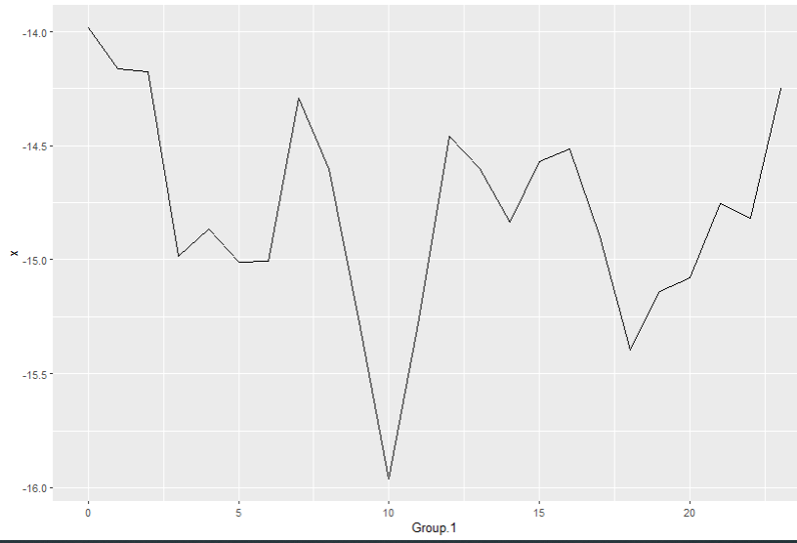
ggplot(Mar29SNRbyHR , aes(x = Group.1, y = x) ) +geom_line()
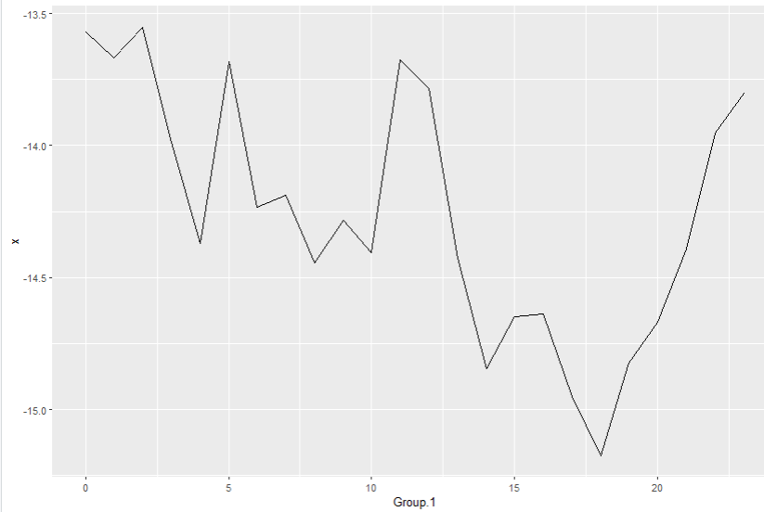
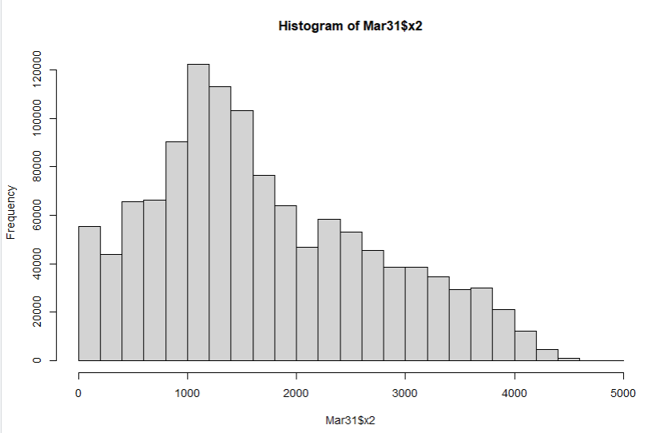
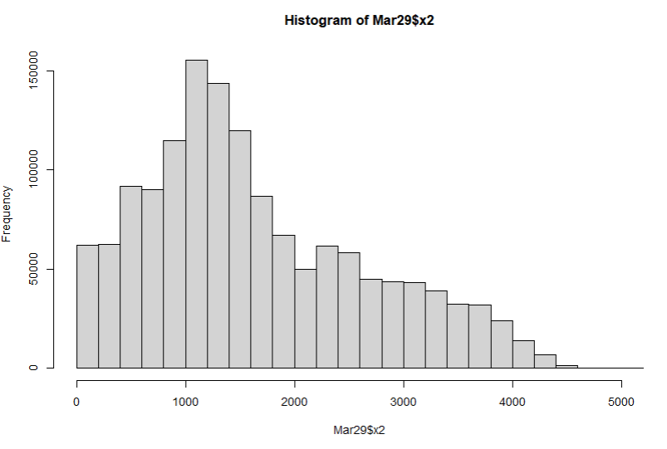

names(Mar31SNRbyHR) <- c("Hour", "AvgSNR")
names(Mar29SNRbyHR) <- c("Hour", "AvgSNR")

Mar29COUNTbyHR <- aggregate(Mar29$hr, list(Mar29$hr), FUN = length)
names(Mar29COUNTbyHR) <- c("Hour", "Reports")
ggplot(Mar29COUNTbyHR , aes(x = Hour, y = Reports) ) +geom_line()+ggtitle("March 29 2022 - Nbr Observations per hour on 40 meters")

and for March 31

# Line of Sight
Mar29LT100m <- Mar29[Mar29$x2 >1 & Mar29$x2 <100,]
# NVIS 100 to 500 miles
Mar29LT500m <- Mar29[Mar29$x2 >100 & Mar29$x2 < 500,]
# E-layer 500 to 1500 miles
Mar29LT1500m <- Mar29[Mar29$x2 >500 & Mar29$x2 < 1500,]
# F-layer over 1500 miles
Mar29GT1500m <- Mar29[Mar29$x2 > 1500,]

# Line of Sight
Mar31LT100m <- Mar31[Mar31$x2 >1 & Mar31$x2 <100,]
# NVIS 100 to 500 miles
Mar31LT500m <- Mar31[Mar31$x2 >100 & Mar31$x2 < 500,]
# E-layer 500 to 1500 miles
Mar31LT1500m <- Mar31[Mar31$x2 >500 & Mar31$x2 < 1500,]
# F-layer over 1500 miles
Mar31GT1500m <- Mar31[Mar31$x2 > 1500,]

# Average SNR by hour, categorized by distance beween transmitter and receiver
Mar29LT100mSNRbyHR <- aggregate(Mar29LT100m$SNR, list(Mar29LT100m$hr), FUN = mean)
names(Mar29LT100mSNRbyHR) <- c("Hour", "AvgSNR")
Mar29LT500mSNRbyHR <- aggregate(Mar29LT500m$SNR, list(Mar29LT500m$hr), FUN = mean)
names(Mar29LT500mSNRbyHR) <- c("Hour", "AvgSNR")
Mar29LT1500mSNRbyHR <- aggregate(Mar29LT1500m$SNR, list(Mar29LT1500m$hr), FUN = mean)
names(Mar29LT1500mSNRbyHR) <- c("Hour", "AvgSNR")
Mar29GT1500mSNRbyHR <- aggregate(Mar29GT1500m$SNR, list(Mar29GT1500m$hr), FUN = mean)
names(Mar29GT1500mSNRbyHR) <- c("Hour", "AvgSNR")
Mar31LT100mSNRbyHR <- aggregate(Mar31LT100m$SNR, list(Mar31LT100m$hr), FUN = mean)
names(Mar31LT100mSNRbyHR) <- c("Hour", "AvgSNR")
Mar31LT500mSNRbyHR <- aggregate(Mar31LT500m$SNR, list(Mar31LT500m$hr), FUN = mean)
names(Mar31LT500mSNRbyHR) <- c("Hour", "AvgSNR")
Mar31LT1500mSNRbyHR <- aggregate(Mar31LT1500m$SNR, list(Mar31LT1500m$hr), FUN = mean)
names(Mar31LT1500mSNRbyHR) <- c("Hour", "AvgSNR")
Mar31GT1500mSNRbyHR <- aggregate(Mar31GT1500m$SNR, list(Mar31GT1500m$hr), FUN = mean)
names(Mar31GT1500mSNRbyHR) <- c("Hour", "AvgSNR")

# Add date of observation, to allow comparison in ggplot
Mar29LT100mSNRbyHR$dt <- "Mar29"
Mar29LT500mSNRbyHR$dt <- "Mar29"
Mar29LT1500mSNRbyHR$dt <- "Mar29"
Mar29GT1500mSNRbyHR$dt <- "Mar29"
Mar31LT100mSNRbyHR$dt <- "Mar31"
Mar31LT500mSNRbyHR$dt <- "Mar31"
Mar31LT1500mSNRbyHR$dt <- "Mar31"
Mar31GT1500mSNRbyHR$dt <- "Mar31"

Starting over – March 7 2024

> Mar30$HR <- as.numeric(substring(Mar30$Datetime, nchar(Mar30$Datetime)-7, nchar(Mar30$Datetime)-6))
> Mar30$MIN <- as.numeric(substring(Mar30$Datetime, nchar(Mar30$Datetime)-4, nchar(Mar30$Datetime)-3))
> Mar30$HRtenth <- Mar30$HR + (Mar30$MIN/60)
> hist(Mar30$MIN)
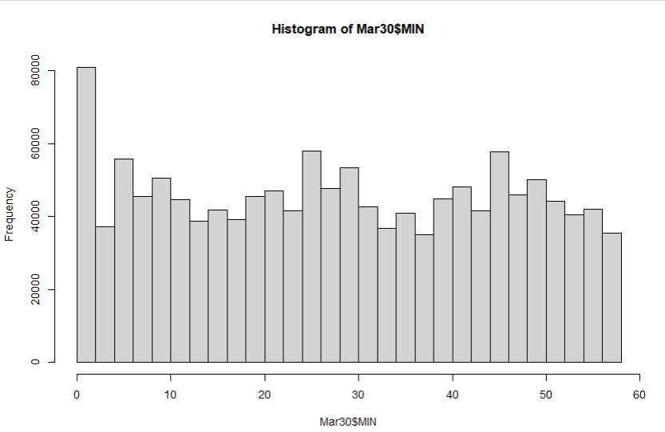

> Mar30SNRbyHR <- aggregate(Mar30$SNR, list(Mar30$HR), FUN = mean)
> Mar30SNRbyHRtenth <- aggregate(Mar30$SNR, list(Mar30$HRtenth), FUN = mean)

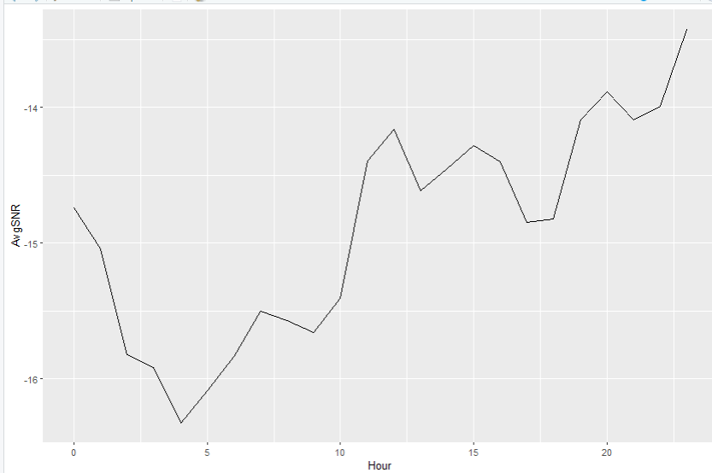

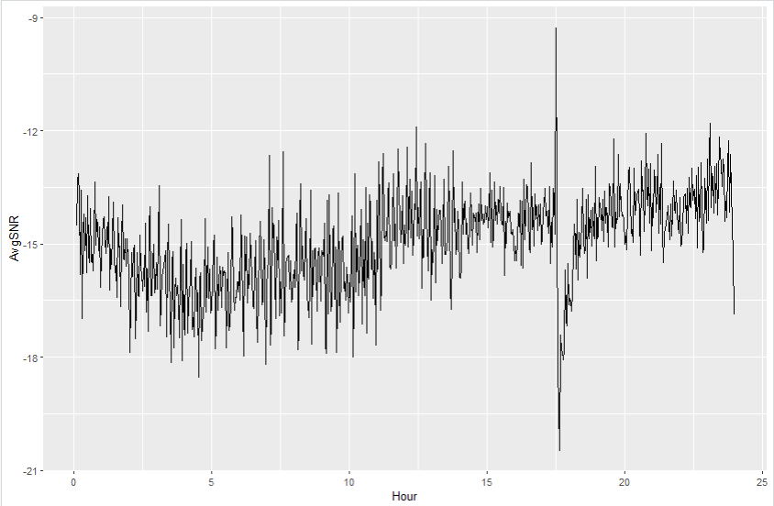

Now distance per hour

